BRAMLEY AVENUE SURGERY
WINTER NEWSLETTER

WELCOME to the winter edition of our newsletter
The winter months can be challenging for the NHS, especially for urgent care services.
Here are some top tips for keeping well this winter.
- Medicine Cabinet - Keep a range of over-the-counter medicines suitable for you and your family in stock. (E.g. paracetamol; Ibuprofen; cough & cold medication, heartburn/indigestion tablets; anti-diarrhoea medication & rehydration salts.
- Get Your Flu Jab – If you are over 65 or between 2 – 10 years old; pregnant; have a long term health condition or are a carer you are eligible for a FREE flu vaccination. So don’t delay, please phone us today on 020 660 0193 and book your appointment with one of the Practice Nurses.
- Pharmacy First – If you start to feel unwell with a winter illness, even if it’s just a cough or cold, consult your local pharmacy team before it gets worse.
- Not Sure What To Do – You can call NHS 111 anytime of the day or night. They will give you professional advice and support and will make sure you get the care you need, whether that’s advice and support, booking a GP or Urgent Care appointment or if it’s more serious calling an ambulance for you.

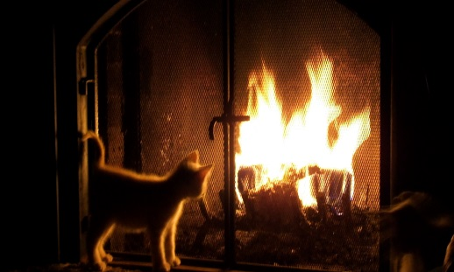

Keep Your Home Warm

Follow these tips to keep you and our family warm and well at home
- If you are not very mobile, are 65 or over, or have a health condition, such as heart or lung disease, heat your home to at least18C.
- Keep your bedroom at 18C all night if you can – and keep the bedroom window closed.
- If you are under 65, heathy and active, you can safely have your home cooler than 18C, as long as you are comfortable.
- Use a hot water bottle or electric blanket to keep warm in bed – but do not use both at the same time.
- Have at least one hot meal a day – eating regularly helps keep you warm.
- Have hot drinks regularly.
- Draw curtains at dusk and keep doors closed to block out draughts.
- Get your heating system checked regularly by a qualified professional.

Look In On Vulnerable Neighbours and Relatives
- Make sure they are safe and well
- Are warm enough, especially at night
- Have stocks of food and medicine
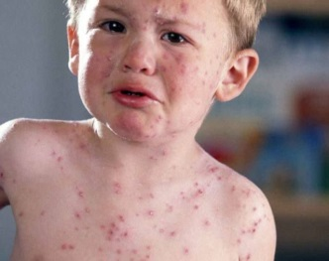 MEASLES
There has been a significant increase in the instances of measles this year. The MMR vaccine remains the most effective protection against measles. If your child is between 13months and 18 Years and has not had the two dose course, please book an appointment with one of our practice nurses.

PATIENT PARICIPATION GROUP (PPG)
If you would like to help us improve our services then PLEASE join our Patient Participation Group. The Chairperson is Diane Hearne and her contact details are on the PPG notice board in the surgery. Please check the notice board for information of up talks and events. The next PPG meeting is on Wednesday 22nd January 2020 at 6pm – 7pm; so why not come along and see what we are about.

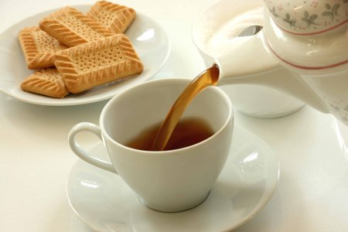

“CHIT-CHAT” DROP IN
Your Patient Participation Group (PPG) has been hosting informal ‘drop in’s’ on the first Wednesday of each month, where you come along for tea, coffee, cake, biscuits, a chat and make new friends. So why not come and join us. The drop-in for January will on:
WEDNESDAY 8th JANUARY 2020
TIME: 2.30pm – 4pm

Surgery Opening Times

Morning Evening
Monday 08.30 – 13.00 15.30 – 18.30
Tuesday 08.30 - 13.00 16.00 - 19.30
Wednesday 08.30 – 13.00 CLOSED
Thursday 08.30 – 13.00 15.30 – 18.30
Friday 08.30 – 13.00 16.30 – 18.30

FUND RAISER
A BIG thank you to all those who came to our Christmas fund raiser for the MS Therapy Centre in Lloyd Avenue Coulsdon. We managed to raise £164.60.

We would like to give a BIG THANK YOU to Judy Taylor for the beautiful handmade cards she gave us to sell on behalf of the MS Therapy Centre.

Dr Gooneratne and staff would like to wish you a Wonderful Christmas and a Healthy and Happy New Year

CHRISTMAS & NEW YEAR
CLOSURES
Wednesday 25th December 2019
(Christmas Day)
Thursday 26th December 2019
(Boxing Day)
Wednesday 1st January 2020
(New Year’s Day)

